J2ME Sample Game 11 - Write Read Mixed Data Types Example

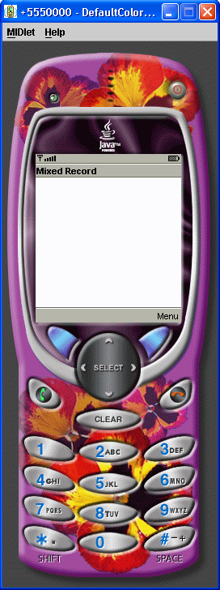

/*
J2ME: The Complete Reference
James Keogh
Publisher: McGraw-Hill
ISBN 0072227109
*/
//jad file (please verify the jar size)
/*
MIDlet-Name: WriteReadMixedDataTypesExample
MIDlet-Version: 1.0
MIDlet-Vendor: MyCompany
MIDlet-Jar-URL: WriteReadMixedDataTypesExample.jar
MIDlet-1: WriteReadMixedDataTypesExample, ,
WriteReadMixedDataTypesExample
MicroEdition-Configuration: CLDC-1.0
MicroEdition-Profile: MIDP-1.0
MIDlet-JAR-SIZE: 100
*/
import javax.microedition.rms.*;
import javax.microedition.midlet.*;
import javax.microedition.lcdui.*;
import java.io.*;
public class WriteReadMixedDataTypesExample
extends MIDlet implements CommandListener
{
private Display display;
private Alert alert;
private Form form;
private Command exit;
private Command start;
private RecordStore recordstore = null;
public WriteReadMixedDataTypesExample ()
{
display = Display.getDisplay(this);
exit = new Command("Exit", Command.SCREEN, 1);
start = new Command("Start", Command.SCREEN, 1);
form = new Form("Mixed Record");
form.addCommand(exit);
form.addCommand(start);
form.setCommandListener(this);
}
public void startApp()
{
display.setCurrent(form);
}
public void pauseApp()
{
}
public void destroyApp( boolean unconditional )
{
}
public void commandAction(Command command, Displayable displayable)
{
if (command == exit)
{
destroyApp(true);
notifyDestroyed();
}
else if (command == start)
{
try
{
recordstore = RecordStore.openRecordStore(
"myRecordStore", true );
}
catch (Exception error)
{
alert = new Alert("Error Creating",
error.toString(), null, AlertType.WARNING);
alert.setTimeout(Alert.FOREVER);
display.setCurrent(alert);
}
try
{
byte[] outputRecord;
String outputString = "First Record";
int outputInteger = 15;
boolean outputBoolean = true;
ByteArrayOutputStream outputStream = new ByteArrayOutputStream();
DataOutputStream outputDataStream =
new DataOutputStream(outputStream);
outputDataStream.writeUTF(outputString);
outputDataStream.writeBoolean(outputBoolean);
outputDataStream.writeInt(outputInteger);
outputDataStream.flush();
outputRecord = outputStream.toByteArray();
recordstore.addRecord(outputRecord, 0, outputRecord.length);
outputStream.reset();
outputStream.close();
outputDataStream.close();
}
catch ( Exception error)
{
alert = new Alert("Error Writing",
error.toString(), null, AlertType.WARNING);
alert.setTimeout(Alert.FOREVER);
display.setCurrent(alert);
}
try
{
String inputString = null;
int inputInteger = 0;
boolean inputBoolean = false;
byte[] byteInputData = new byte[100];
ByteArrayInputStream inputStream = new ByteArrayInputStream(byteInputData);
DataInputStream inputDataStream =
new DataInputStream(inputStream);
for (int x = 1; x <= recordstore.getNumRecords(); x++)
{
recordstore.getRecord(x, byteInputData, 0);
inputString = inputDataStream.readUTF();
inputBoolean = inputDataStream.readBoolean();
inputInteger = inputDataStream.readInt();
inputStream.reset();
}
inputStream.close();
inputDataStream.close();
alert = new Alert("Reading", inputString + " " +
inputInteger + " " +
inputBoolean, null, AlertType.WARNING);
alert.setTimeout(Alert.FOREVER);
display.setCurrent(alert);
}
catch (Exception error)
{
alert = new Alert("Error Reading",
error.toString(), null, AlertType.WARNING);
alert.setTimeout(Alert.FOREVER);
display.setCurrent(alert);
}
try
{
recordstore.closeRecordStore();
}
catch (Exception error)
{
alert = new Alert("Error Closing",
error.toString(), null, AlertType.WARNING);
alert.setTimeout(Alert.FOREVER);
display.setCurrent(alert);
}
if (RecordStore.listRecordStores() != null)
{
try
{
RecordStore.deleteRecordStore("myRecordStore");
}
catch (Exception error)
{
alert = new Alert("Error Removing",
error.toString(), null, AlertType.WARNING);
alert.setTimeout(Alert.FOREVER);
display.setCurrent(alert);
}
}
}
}
}

